Instituto Tecnológico y de Estudios Superiores de Monterrey
EGADE Business School



Productos Derivados y Administración de Riesgos Corporativos
Clase 5

Profesor

PhD Raymundo Díaz Robles

Integrantes:
- Adrián Villarreal Beltrán | A00820629
- Héctor Guillermo Fuentes González | A01452149

Fecha: 27 / 10 / 2026
Clase 5 – Estrategias Compras de Opciones de Subyacentes con Árboles
Se evaluaron 5 subyacentes y se hicieron operaciones de Trading View

TSLA

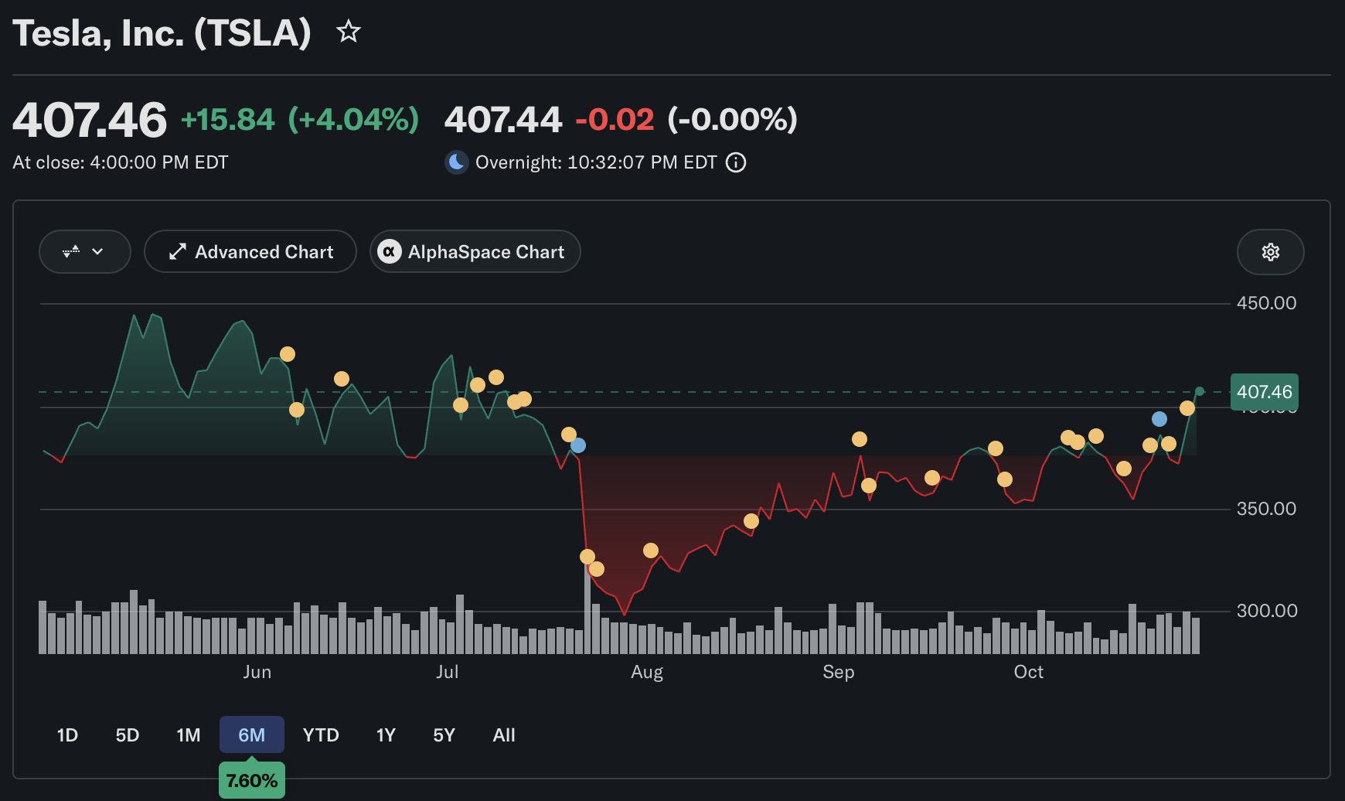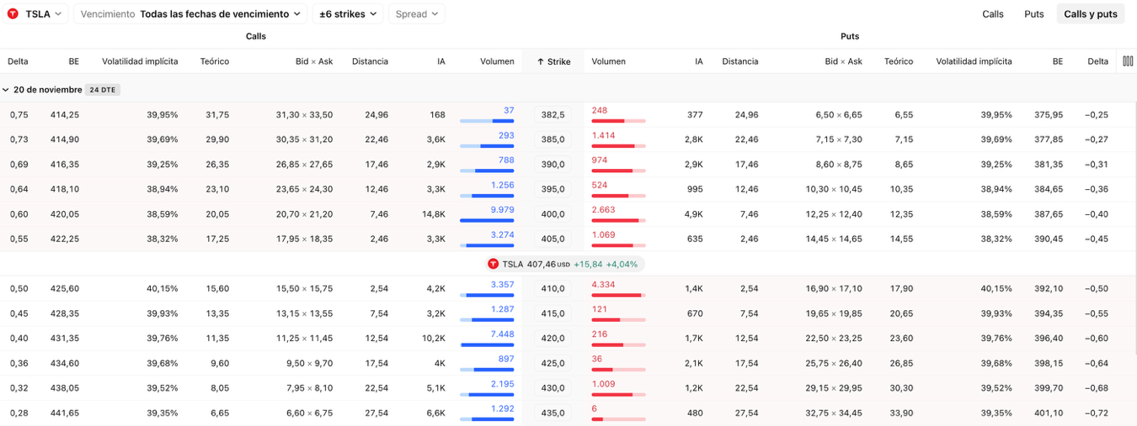

SPCX

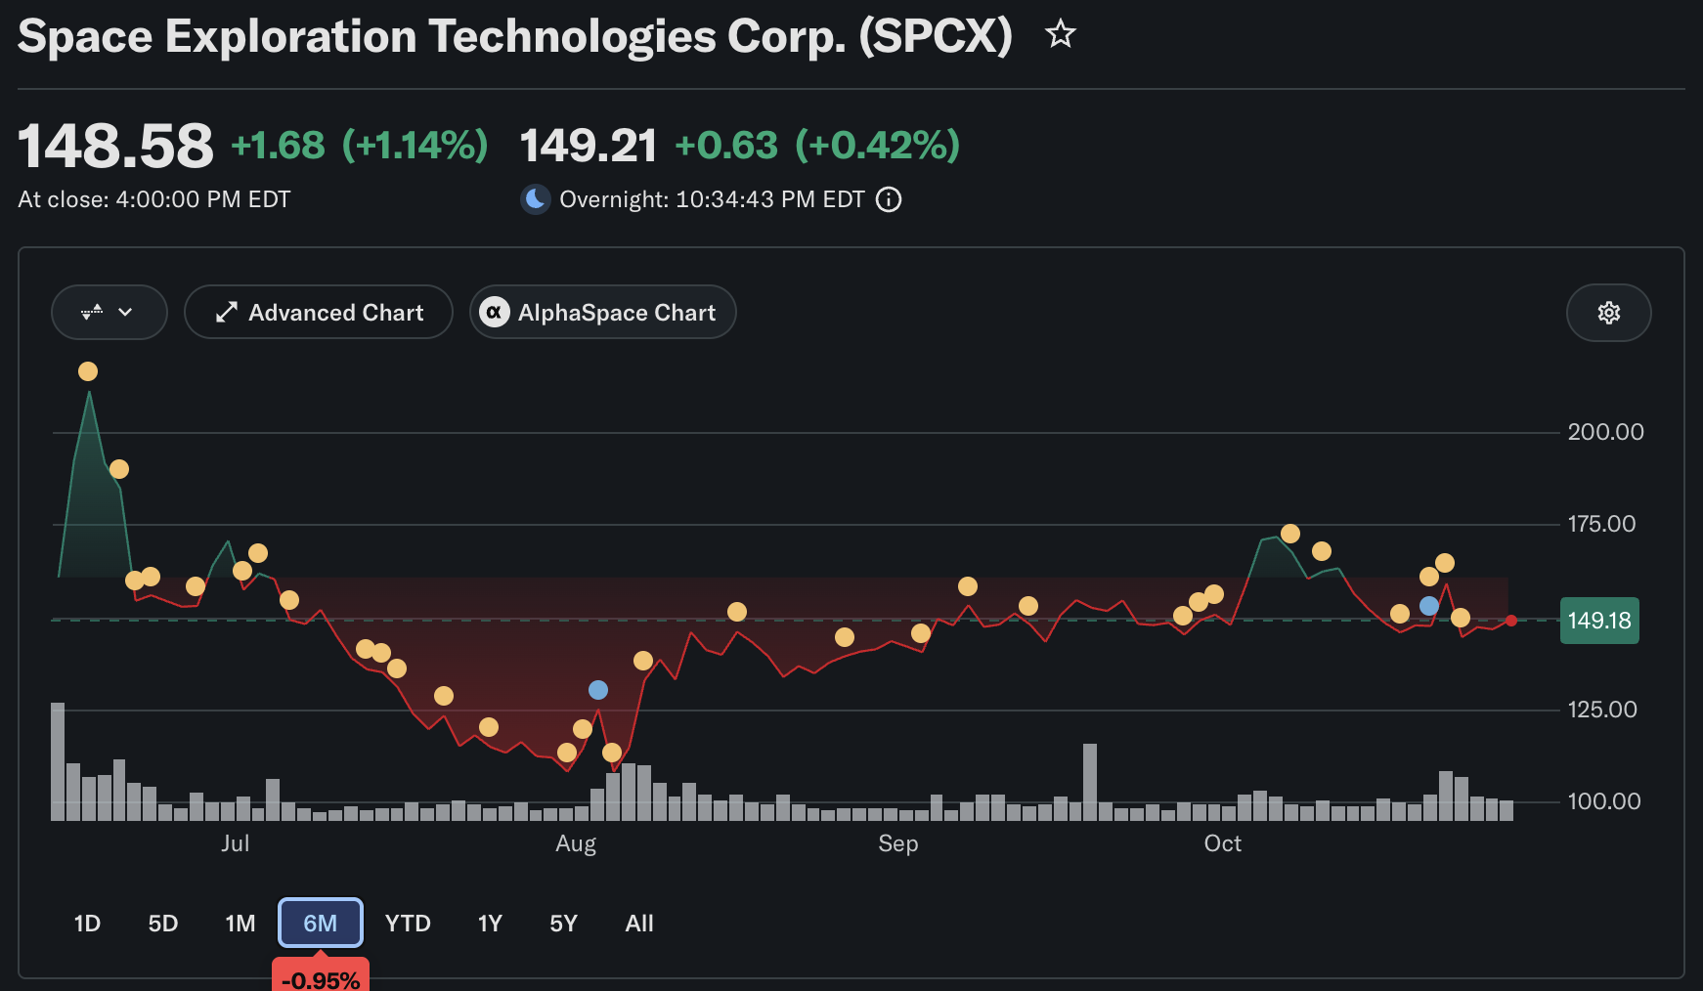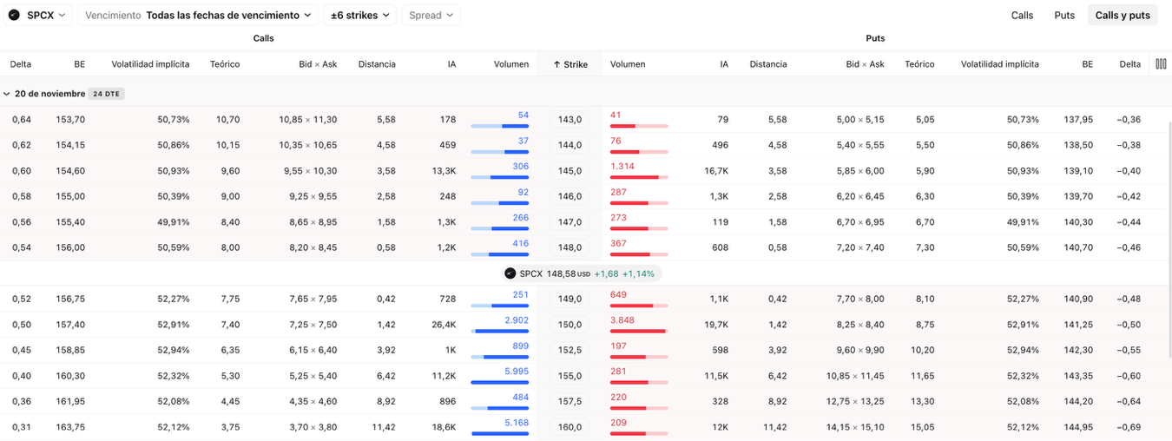

MU
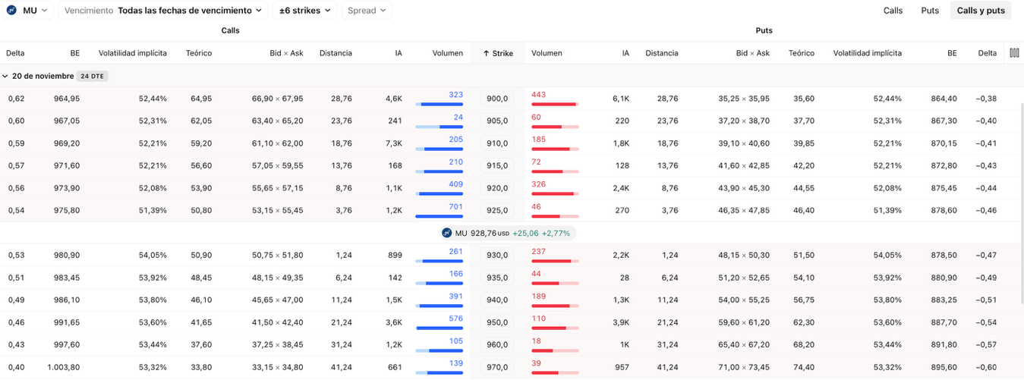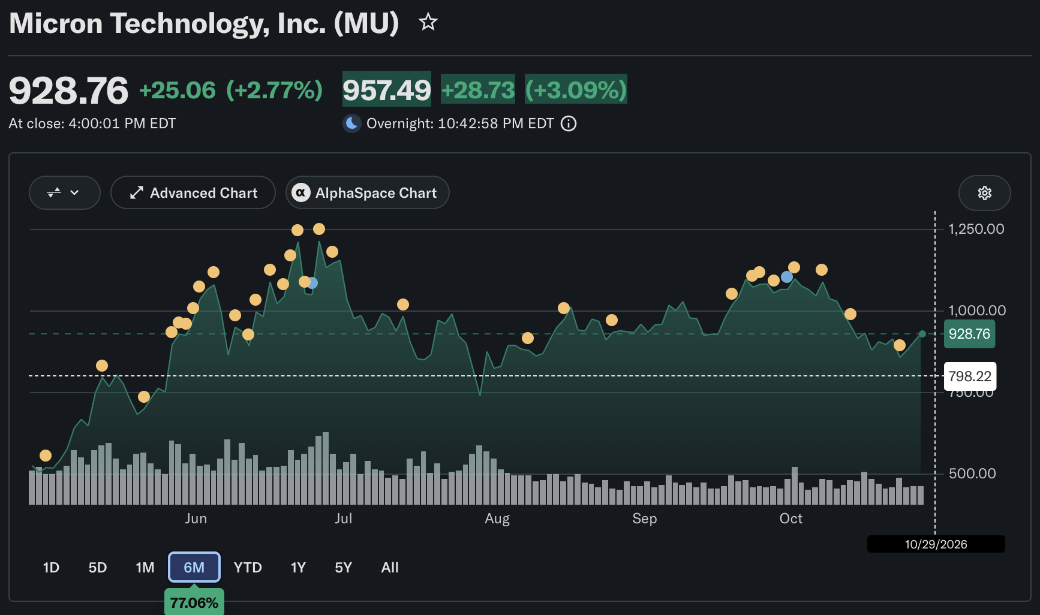

SPY
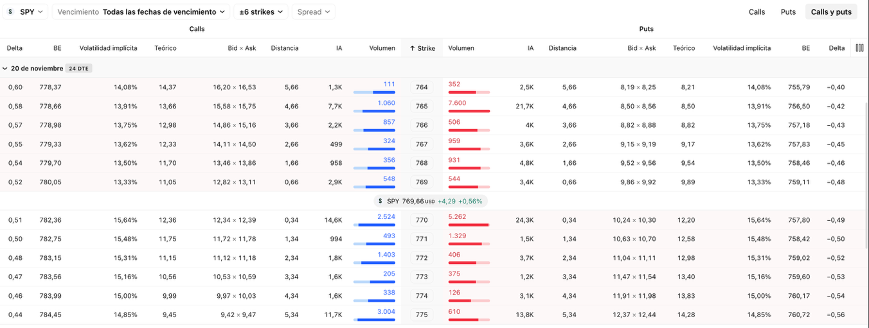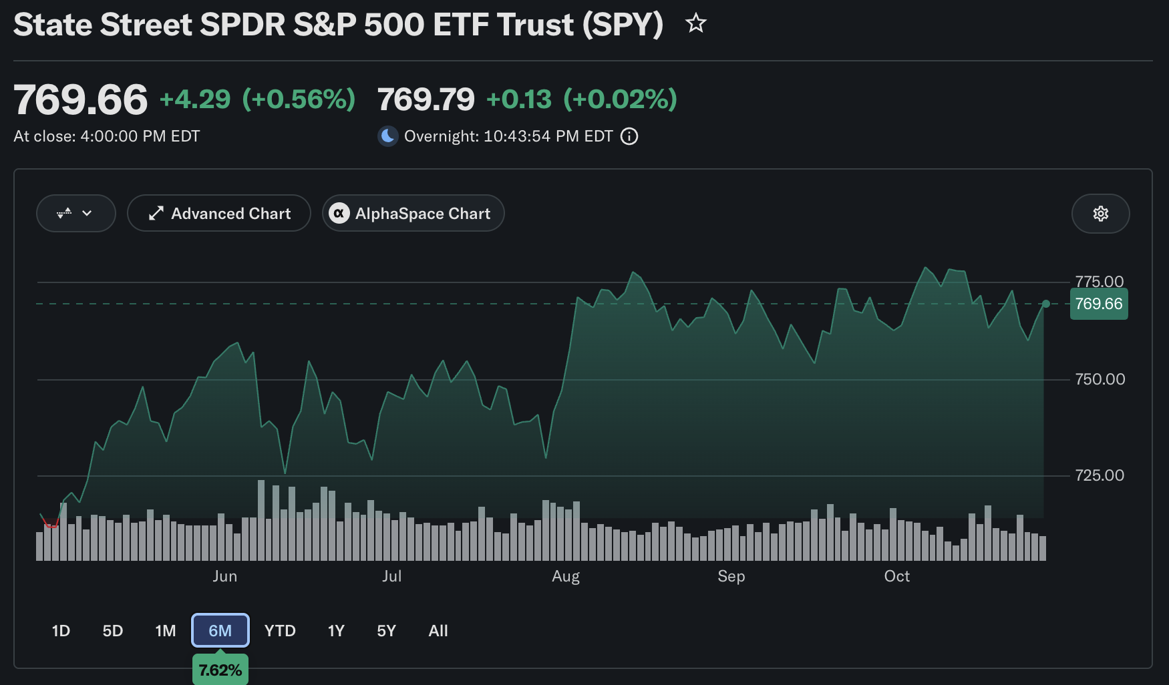

Micro E-Mini Nasdaq
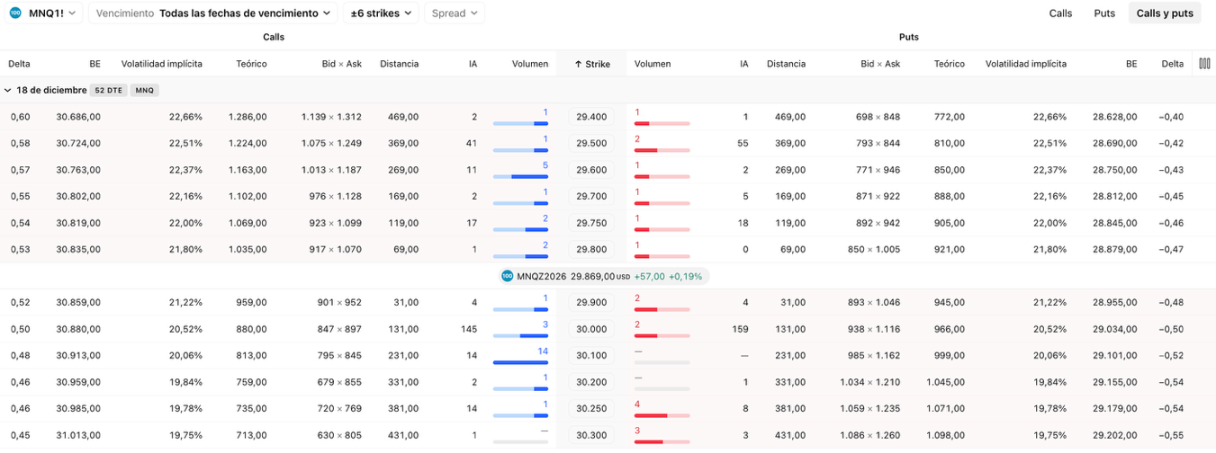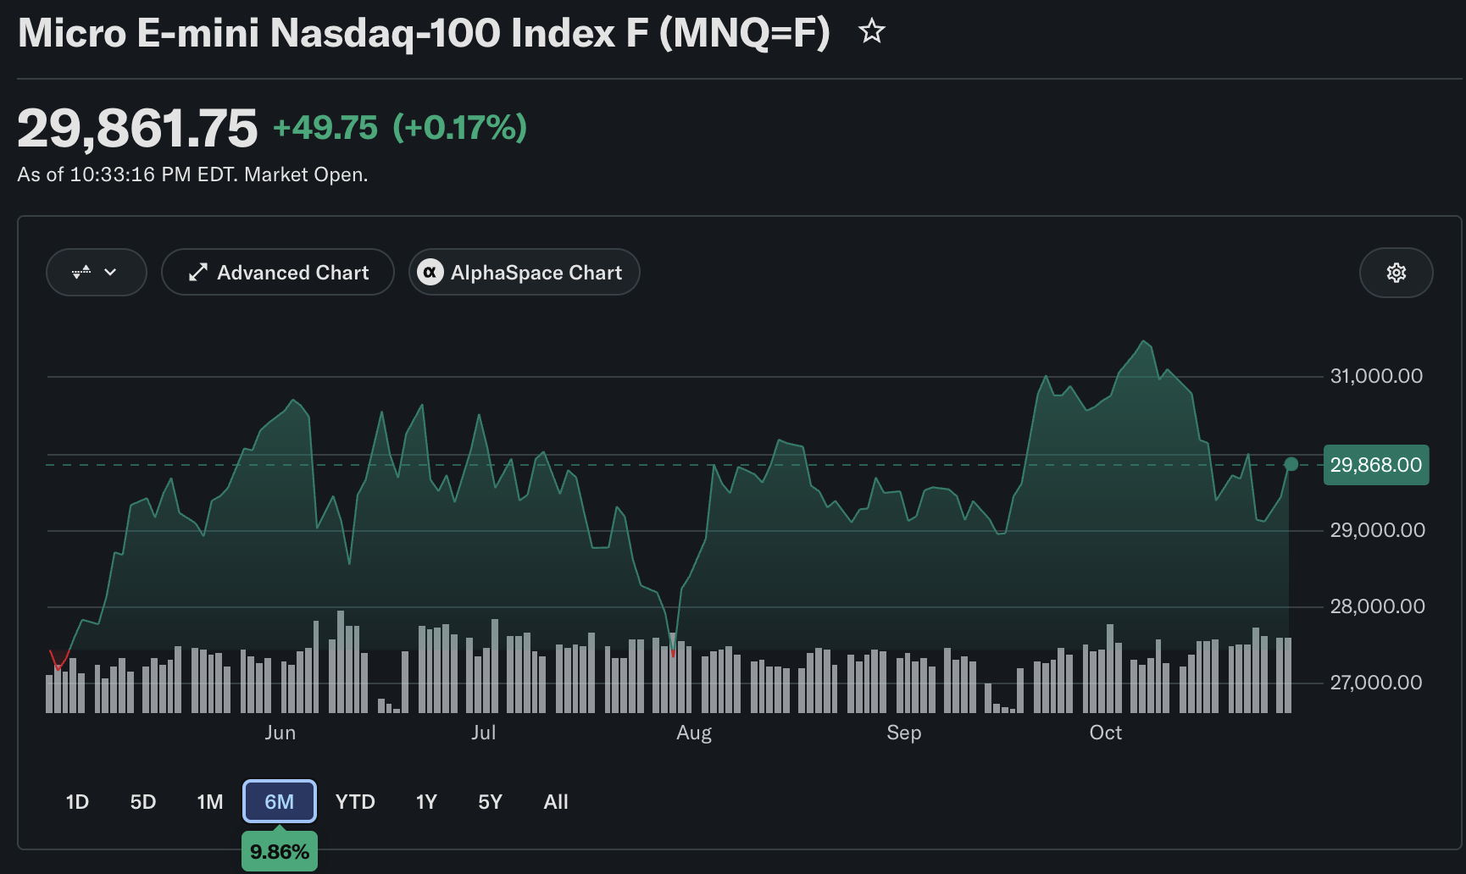

Comprobación de Trades -
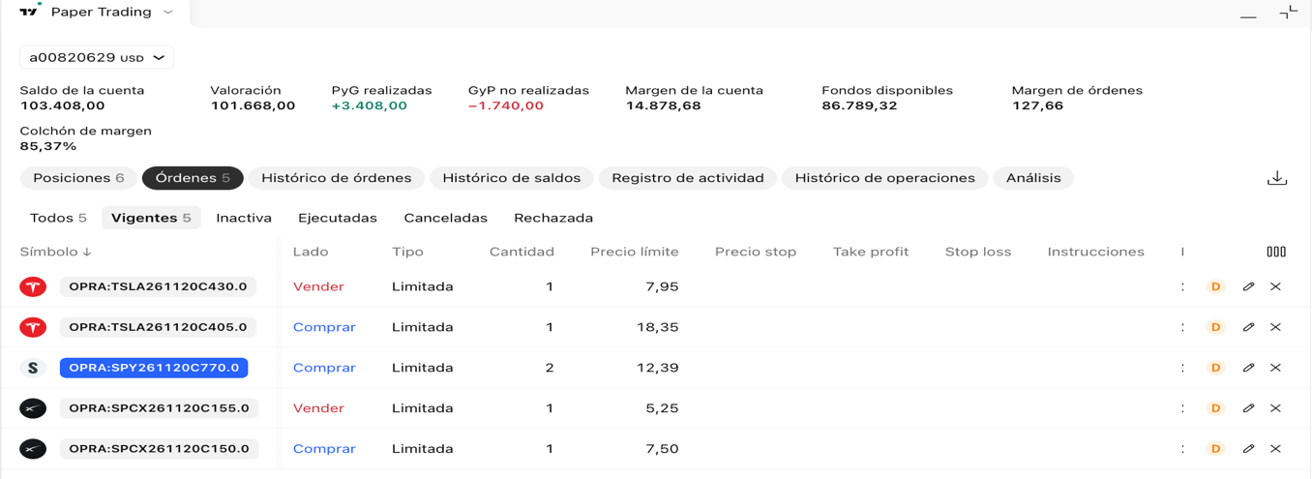

Activo | Estrategia | Patas | Pago máximo (pérdida máx.) | Ganancia máx. | Equilibrio
TSLA | Bull call spread | Compro call 405 (ask 18.35), vendo call 430 (bid 7.95) | $1,040 | $1,460 | 415.40 (+1.9%)
SPCX | Bull call spread | Compro call 150 (ask 7.50), vendo call 155 (bid 5.25) | $225 | $275 | 152.25 (+2.5%)
SPY | Call larga | Compro call 770 (ask 12.39) | $1,239 | Sin tope | 782.39 (+1.7%)
MU | Esperar | No abrir hoy | n/a | n/a | n/a
MNQ | No operar | n/a | n/a | n/a | n/a
Por qué cada una
- TSLA y SPCX: son los spreads con mejor relación ganancia-pérdida (1.40 a 1 y 1.22 a 1) y buena liquidez en esos strikes. Un call solo costaría casi el doble.
- SPY: el call spread 770/775 es mala idea (ganancia $203 por riesgo de $297). La call sola cuesta 1.6% del precio, tiene los spreads más angostos y el menor costo de volatilidad.
- MU: fuera de horario subió 3.1% (a 957.49), así que estas primas ya están desactualizadas. Revisen la cadena al abrir y, si quieren entrar, el spread que calculé era el 930/970.
- MNQ: los volúmenes son de 1 a 14 contratos y los spreads bid-ask son de 5% a 24%.

Preguntas 23.1 al 23.6 de John Hull del Capitulo 23

23.1. Explain the exponentially weighted moving average (EWMA) model for estimating volatility from historical data.
The EWMA model estimates daily variance as a moving average whose weights decline exponentially into the past.
- Formula: σₙ² = λσₙ₋₁² + (1 − λ)uₙ₋₁², with 0 < λ < 1.
- Return: uᵢ = (Sᵢ − Sᵢ₋₁)/Sᵢ₋₁, with the mean assumed to be zero.
- Weights: the observation from i days ago gets weight (1 − λ)λⁱ⁻¹, so recent data count more.
- Practical advantage: only the latest variance estimate and the latest return need to be stored. RiskMetrics uses λ = 0.94.
- Effect of λ: a high λ makes the estimate change slowly. A low λ makes it react quickly to recent moves.
23.2. What is the difference between the exponentially weighted moving average model and the GARCH(1,1) model for updating volatilities?
- GARCH(1,1): σₙ² = ω + αuₙ₋₁² + βσₙ₋₁², where ω = γV_L and γ + α + β = 1. V_L is the long-run variance.
- Relationship: EWMA is a special case with ω = 0, α = 1 − λ and β = λ.
- Key difference: GARCH has mean reversion, because variance is pulled toward V_L = ω/(1 − α − β). EWMA has none, so its forecast of future variance equals the current estimate.
23.3. The most recent estimate of the daily volatility of an asset is 1.5% and the price of the asset at the close of trading yesterday was $30.00. The parameter l in the EWMA model560 CHAPTER 23 is 0.94. Suppose that the price of the asset at the close of trading today is $30.50. How will this cause the volatility to be updated by the EWMA model?
- Today’s return: u = (30.50 − 30.00)/30.00 = 1.6667%.
- σₙ² = 0.94 × (0.015)² + 0.06 × (0.016667)² = 0.0002115 + 0.0000167 = 0.00022817.
- σₙ = 1.5105%.
Daily volatility rises from 1.50% to about 1.51%. Today’s return was slightly larger than the previous volatility estimate, but it carries only a 6% weight.
23.4. A company uses an EWMA model for forecasting volatility. It decides to change the parameter l from 0.95 to 0.85. Explain the likely impact on the forecasts.
- Forecasts react faster to recent returns, because the weight on the latest observation rises from 5% to 15%.
- They become more volatile and noisier, since they rely on fewer observations. The effective memory drops from about 20 days (1/(1 − λ)) to about 7.
- A day with a large move shifts the estimate much more, and its effect fades sooner.
23.5. The volatility of a certain market variable is 30% per annum. Calculate a 99% confidence interval for the size of the percentage daily change in the variable.
- Daily volatility = 30%/√252 = 1.89%.
- For 99% confidence we use 2.576 standard deviations: 2.576 × 1.89% = 4.87%.
- The daily percentage change should lie between −4.87% and +4.87% with 99% confidence. Using 365 days instead of 252 would give ±3.97%.
23.6. A company uses the GARCH(1,1) model for updating volatility. The three parameters are v, a, and b. Describe the impact of making a small increase in each of the parameters while keeping the others fixed.
- ω: raises the long-run variance V_L = ω/(1 − α − β), so forecasts and the level that variance reverts to are higher. Everything else is unchanged.
- α: the latest return gets more weight, so volatility reacts more strongly to recent shocks. It also raises persistence (α + β) and V_L, and mean reversion becomes slower.
- β: more weight goes to the previous variance, so volatility changes more slowly and is more persistent. It also raises V_L and slows mean reversion.

